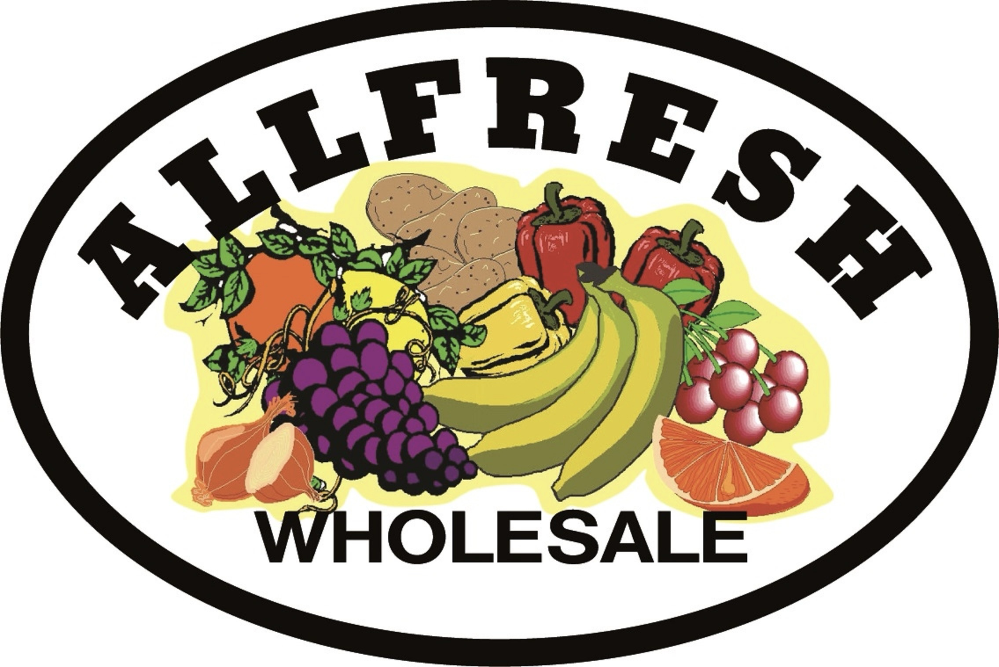

Allfresh
Sustainability Report

GROWING A GREENER FUTURE, PIONEERING LOW CARBON &
PLASTIC FREE SOLUTIONS

Allfresh Sustainability Report

Introduction

At Allfresh sustainability is more than a buzzword—it is the foundation of our mission and the driving force behind every decision we make. As a fruit and vegetable wholesaler, we are acutely aware of the environmental impact of our operations, from sourcing and packaging to transportation and waste management.
We believe that sustainability is a shared responsibility. By working closely with our dedicated team, suppliers and loyal customers, we strive to make meaningful changes that reduce our environmental footprint while supporting local communities and ecosystems.
Together we aim to drive progress in the wholesale food industry and set a standard for sustainable practices. We believe it’s time to act now before it’s too late.

Commitment to Local Sourcing

Supporting local first.
At Allfresh sourcing Irish-grown produce is a core principle. By prioritizing local growers we contribute to the local economy, reduce transportation emissions and deliver the freshest produce to our customers.
When Irish produce is unavailable due to seasonality, we carefully select European alternatives, ensuring that we always choose the option with the least environmental impact. This commitment to transparency and sustainability strengthens our relationships with customers who trust us to make the best choices for both the planet and their plates.

Import Substitution/Local Sourcing
01/11/24–01/11/25:
Significant progress was made in replacing imported products with Irish-grown alternatives, strengthening our local supply chain and reducing food miles.
- Large Onions: In 2024/2025, 48% of our large onions were sourced from the Irish grower Castlecor, marking a significant move toward reducing our reliance on imports. This represents a major improvement compared to five years ago, when all onions were imported.
- Pak Choi: Transitioned entirely to Irish-grown, eliminating the need for imported alternatives.
- Garryhinch Mushrooms: Increased Irish sourcing for key varieties including Shitake (41%), Oyster (55%), Maitake (32%) and Mixed Wild Mushrooms (43%).
- Trio Mixed Lettuce: Previously imported. Now 100% sourced from Ireland.
- Courgettes and Cucumbers: 45% of courgettes are Irish and now 35% of cucumbers are Irish grown. AIM in 2026? is to improve this to over 50%.
- Broccoli – In the last year, 46% of broccoli sold is Irish. We aim to increase this proportion in the coming year to support local growers and strengthen our sustainable sourcing.
- Basil: 50% of our basil is now grown in Ireland with further progress anticipated in the coming years.
- Apples- 100% of our cooking apples are Irish. For eating apples, there is an opportunity to increase the proportion sourced from Ireland, and we aim to maximise this in the future.
- Peeled Brussel Sprouts: In 2024 we sold 100% Irish peeled brussels sprouts, no imported. 200 x 5kg = 1000kg bought in Ireland rather than Holland. We will hopefully be able to get the supply to do the same this year.
- Chipping Potatoes- In 2025, we sold 32,859 bags of 25kg potatoes (a total of 821.5 tonnes). Traditionally, 80% of this volume came from the UK, but we are now delighted that we supply 100% Irish and source the majority from Denis O’Connor in Ballyvodock, just down the road from our base in Midleton. All remaining volumes were supplied by other Irish growers, further strengthening our local supply chain and reducing transport-related impact.
- Sauces & Mayo- 90% of our sauces come from Global Sauces- manufactured in Ireland
- Juices- 100% of our juices are supplied from Sunshine Juices.
- Spring Onions-. In the past 12 months, we sold 8,140 bags of spring onions, with 3,100 bags(38%) sourced from Ireland.
- Celery - Last year, we sold 3,715 boxes, with 1,687(45%) of them sourced from Ireland. We always try to choose Irish produce whenever it is available.
- Recent Initiatives – Over the past few months, we have conducted trials of Irish red and green chillies and garlic which we sourced from Taylors in Lusk. Additionally, we have partnered with artisan growers such as Dripsey Castle and Leslie Bryan in Kinsale to bring unique, top-quality produce to our customers.

By increasing our reliance on local produce we have significantly reduced air miles, supported Irish growers, and ensured that our customers receive the freshest products possible. However we recognize there is still more to do especially in categories such as eating apples, cucumbers, mixed lettuce, garlic and chillies.
In 2025, we engaged with local growers and have further meetings planned to grow these partnerships. By guaranteeing fixed quantities and fixed prices, we reduce growers’ risk and take on part of that risk ourselves to support a more resilient local supply chain.
Driving Plastic-Free Solutions
“NAKED PRODUCE” INITIATIVE
Plastic waste is one of the greatest environmental challenges of our time and Allfresh is proud to be at the forefront of reducing single-use plastic in the wholesale food industry. Through our "naked produce" initiative, we are transitioning away from unnecessary plastic packaging and encouraging our customers to embrace a more sustainable way of buying.

Plastic Packaging Reductions:
From 1/11/24-1/11/25, we eliminated 1Million single-use plastic packs through changes to packaging and product offerings.

- We sell our split / single items by single/kg not in plastic packs like our competitors. We sold 976,646 split items: roughly saving 200,000 plastic packs. Key achievements include:
- Mixed Peppers: Our peppers are 100% loose no plastic. That’s 94,187 less plastic.
- Herbs: Selling herbs loose reduced the use of 173,850 plastic packs.
- Bananas: Eliminated 10,000 plastic bags demonstrating the potential of simple changes.
- Tender Stem Broccoli: Shifted from 200g/500g packs to 1kg and 6kg boxes, cutting 38,840 packets.
- Celery: Currently, 31% of celery is sold “naked,” saving 14,016 plastic packs. Next year, we will prioritise extending this initiative to further minimise plastic waste.
- Cherry Tomatoes (Loose vs. Packed): Our loose cherry tomato initiative continues to reduce plastic use. Over the past 12 months, we sold 12,473 boxes in punnets (32,557kg) and 2,567 boxes loose (10,270kg), eliminating 41,080 plastic packs and making strong progress toward our long-term reduction goals.
- Berries:
  - 80% of strawberries are now sold in 500g punnets,
  - All other berries use cardboard recyclable packaging,
  - This has reduced over 70,000 plastic packs in the past year.
- Grapes: Over the past year, we sold 3,221 boxes, with 1,022 sold loose, achieving a 32% reduction in plastic packs and saving 10,220 packs. We aim to continue this progress and further reduce packaging waste.
- Avocado: Over the past 12 months we sold 6658 boxes of loose avocados that’s 73238 less plastic packets. We only do loose avocados.
- Scallions: We have switched to Irish scallions 3100 less plastic packs we have saved in 2025.
- Cucumbers: In 2025 we sold 2470 boxes and 29,640 less plastic. 23% of our sales were of plastic free cucumbers.
- Other Splits – Unlike our competitors, some of our split products, such as cauliflower, broccoli, and cabbage, are sold loose rather than wrapped in plastic.
These changes highlight the power of collective action. With continued customer support we can eliminate even more plastic from our supply chain.

Opportunities for Future Reductions:
While we have made great strides certain products present challenges that require collaboration with customers and suppliers:
- Cos Lettuce: In the past 12 months, we sold 2,120 boxes, with 253 sold naked, representing 12% of sales and saving 2,530 plastic packs.
- Baby Veg: Irish baby vegetables are sold loose in 1.5kg boxes, while imported varieties come in 8 × 200g packs. Last year, By selling 2,491 loose Irish baby-veg boxes, we avoided 19,928 individual plastic packs compared with the imported pre-packed format.
Minimising waste
Our drivers take back empty boxes, plastic, cardboard, and timber on delivery to reuse and minimise waste supporting a more sustainable cycle.
- Reusing materials for split or smaller deliveries.
- Providing cardboard and plastic boxes to local growers for repurposing in their operations.
ALL PLASTIC & CARDBOARD waste is baled and sent for recycling weekly, ensuring that as little waste as possible enters landfills.
We also offer a plastic returnable crate service, allowing customers to receive their orders in reusable crates instead of disposable packaging. These crates are collected weekly reducing waste and ensuring a circular system that benefits both businesses and the environment.
Addressing Food Waste
We are proud to say that Allfresh has zero food waste. Nothing goes to landfill.
Food waste is a critical global issue and at Allfresh we have implemented innovative solutions to minimize waste while benefiting our community and the environment.
- Discounted Sales: Overstocked items are offered to customers at reduced prices, preventing food from going to waste.
- Charity Donations: Excess produce is donated to organizations like Feed Cork, Penny Dinners, and Fota Island Zoo, ensuring that surplus food reaches those who need it most.
- Animal Feed: Produce unsuitable for human consumption is repurposed for animal feed to local farmers, creating a circular economy that benefits both animals and the environment.

By prioritizing these strategies, we not only reduce landfill waste but also foster a culture of resourcefulness and community support.

Sustainability Consultancy
We offer a free consultancy service designed to help you make more sustainable choices in your food business. Our team will work with you to reduce plastic use, minimize food waste, and lower the carbon footprint. By carefully reviewing your current menu, we can suggest alternative products and ingredients with a lower environmental impact without compromising on quality or taste.

Investing in Energy-Efficient Operations
Energy efficiency and renewable energy are central to Allfresh's sustainability strategy. In 2024, we continued to invest in systems and technologies that reduce our reliance on non-renewable resources.
Solar Power
Our facility is powered by over 90 solar panels, which generated 31% of our total energy use this year. Additionally, 10% of this energy was returned to the grid, contributing to the wider community’s renewable energy supply.
Energy-Efficient Lighting
The store, fridges and offices in Allfresh use LED lighting with automatic sensors. This reduces electricity consumption, lowers carbon emissions, and extends the lifespan of lighting systems, contributing to a more energy-efficient and sustainable operation.
Ad Blue
All of the Allfresh delivery fleet operates with AdBlue systems, which significantly reduce nitrogen oxide emissions. This improves air quality and helps us minimise the environmental footprint of our fleet.
Vehicle Tracking System
Using vehicle tracking systems to optimise delivery routes, helping reduce fuel consumption and emissions while improving overall fleet efficiency. These systems allow us to minimise unnecessary mileage, streamline deliveries, and further lower our environmental impact.
Electric Equipment and Vehicles
- Forklifts: Replaced three diesel forklifts with two electric ones, reducing emissions and operational costs.
- Electric Vehicles: Sales representative Damian now drives an electric car, setting an example for sustainable transport in the food industry.

Exploring HVO Fuel
We are actively researching the potential of Hydrotreated Vegetable Oil (HVO) as a cleaner alternative to diesel for our fleet. HVO produced from renewable resources can reduce greenhouse gas emissions by up to 90%. While adopting HVO presents significant cost challenges, we believe it is a necessary step toward a greener future.

Rainwater Harvesting
We use a rainwater harvesting system to clean our vehicle fleet, reducing demand for freshwater and lowering our environmental impact. This remains a work in progress, and we aim to expand the system’s capacity and increase the ways we use harvested rainwater in the future.

Promoting Ecosystem Support and Biodiversity
Sustainability is not just about reducing waste and emissions—it’s also about enhancing the natural world. At Allfresh we actively support biodiversity and ecosystem health by:
- Planting bee-friendly flowers and trees around our facilities to promote pollinator populations.
- Our eco-friendly insect hotel provides a safe habitat for beneficial insects, supporting biodiversity and enhancing the health of the environment.
- Our beehives are now installed and will support local pollinators, enhance crop yields, and contribute to a healthier environment. They are not yet active, as we are waiting for the upcoming bee season, after which a qualified beekeeper will manage and maintain them.

These measures help us build a healthier environment while ensuring that our operations remain efficient and sustainable.

Ethical Sourcing and Social Responsibility
Sustainability is not just about the environment—it’s also about ensuring a fair and ethical supply chain. At Allfresh we carefully consider the social impact of our sourcing decisions:
- Labor Practices: We avoid sourcing produce from regions where low wages and exploitative labour are prevalent. For example we made the decision to purchase no Israeli produce in 2024/2025.
- Chinese Imports: While 88% of our peeled garlic currently comes from China due to cost, we are actively exploring more sustainable and ethically produced European alternatives. Transitioning will require customer support, as European garlic is more expensive, but progress continues each year.
By holding ourselves to high ethical standards we aim to ensure a sustainable future for both people and the planet.

Setting a Benchmark for Sustainability

At Allfresh, we take pride in leading by example. In the last 12 months, we made significant progress in several key areas:
- Eliminated over 1 million plastic packs through our "naked produce" initiative.
- Transitioned more products to Irish sourcing, reducing air miles and supporting local growers.
- Generated 31% of our energy from solar power, with surplus energy benefiting the grid.
- Reduced emissions by adopting electric forklifts and vehicles.
- Minimized food waste through donations, discounts, and repurposing.

Looking Ahead

We recognize that our sustainability journey is far from over. Key goals for the future include:
- Expanding "naked produce" offerings and encouraging customer buy-in for loose options.
- We are increasing Irish-sourced produce by strengthening partnerships with local growers and using fixed-quantity, fixed-price agreements that improve stability and share risk across the supply chain.
- Transitioning additional products such as Cos lettuce to loose formats plastic free.
- Piloting HVO fuel in our fleet and exploring its long-term viability.
- Enhancing social responsibility by transitioning away from low-cost high-impact imports like Chinese garlic.
Sustainability is a collective effort. Together with our customers and partners, we can achieve a more sustainable, ethical and environmentally responsible future.
Conclusion
At Allfresh, we are not just adapting to sustainability trends—we are shaping them. By reducing plastic use, sourcing locally, minimizing waste, investing in renewable energy and upholding ethical practices, we are setting a new benchmark for the food wholesale industry.
The road ahead requires collaboration, innovation and determination. With your support we can continue to lead the way toward a greener and more sustainable world. Thank you for joining us on this journey. Let’s make a difference—together.

